Research Project for the development of VR environments for people with Autism Spectrum Disorder

TABLE OF CONTENTS

0 Preface 1

0.1 Purpose of this document 1

1 Introduction 2

1.1 Purpose 2

1.2 Scope 2

1.3 Definitions, Acronyms and Abbreviations 2

1.4 References 2

1.5 Overview 2

2 System Overview 3

2.1 System Characteristics 3

2.2 System Architecture 3

3 System Design 4

3.1 Design Method and Standards 4

3.2 Naming conventions 5

3.3 Software development tools 5

3.4 Interactive Progression 6

3.5 System breakdown 7

Document Control 8

Document Change Record 8

0 Preface

0.1 Purpose of this document

To outline all the requirements for the finished project and the time.

# Introduction

## Purpose

* Creating VR environment that can be gamified for people with Autism Spectrum Disorder, and keeping a record for the client.

## Scope

* A Unity Project.
* A list of “rooms” which hold different VR environments with different scenarios for teaching people with Autism Spectrum Disorder how to be neutral typical and build on their strengths.
* The goal is to create a serious game that can be used by people with Autism Spectrum Disorder for teaching.

## Definitions, Acronyms and Abbreviations

|  |  |
| --- | --- |
| *VR* | *Virtual Reality* |
|  |  |

## References

|  |  |  |  |  |
| --- | --- | --- | --- | --- |
| Num. | Title (Applicability & Reference) | Author | Date | Issue |
|  |  |  |  |  |
|  |  |  |  |  |

## Overview

##### Section 1 is the introduction and includes a description of the project, applicable and reference documents.

##### Section 2 provides a system overview.

##### Section 3 contains the system context.

##### Section 4 describes the system design method, standards and conventions.

##### Section 5 contains the component descriptions.

##### Section 6 includes the Requirements Traceability Matrix.

# System Overview

## System Characteristics

* Real-time system, physics-based environments with reactive AI
* The interface should use microphone, hand controllers & game controller translating hand movement, walking, interacting with objects and talking
* Single-player
* Analytical tools for recording the user experience and outcomes from learning
* Tools for adding additional content and modifying the modular content
* Save progress and return to an earlier point for retries

## System Architecture

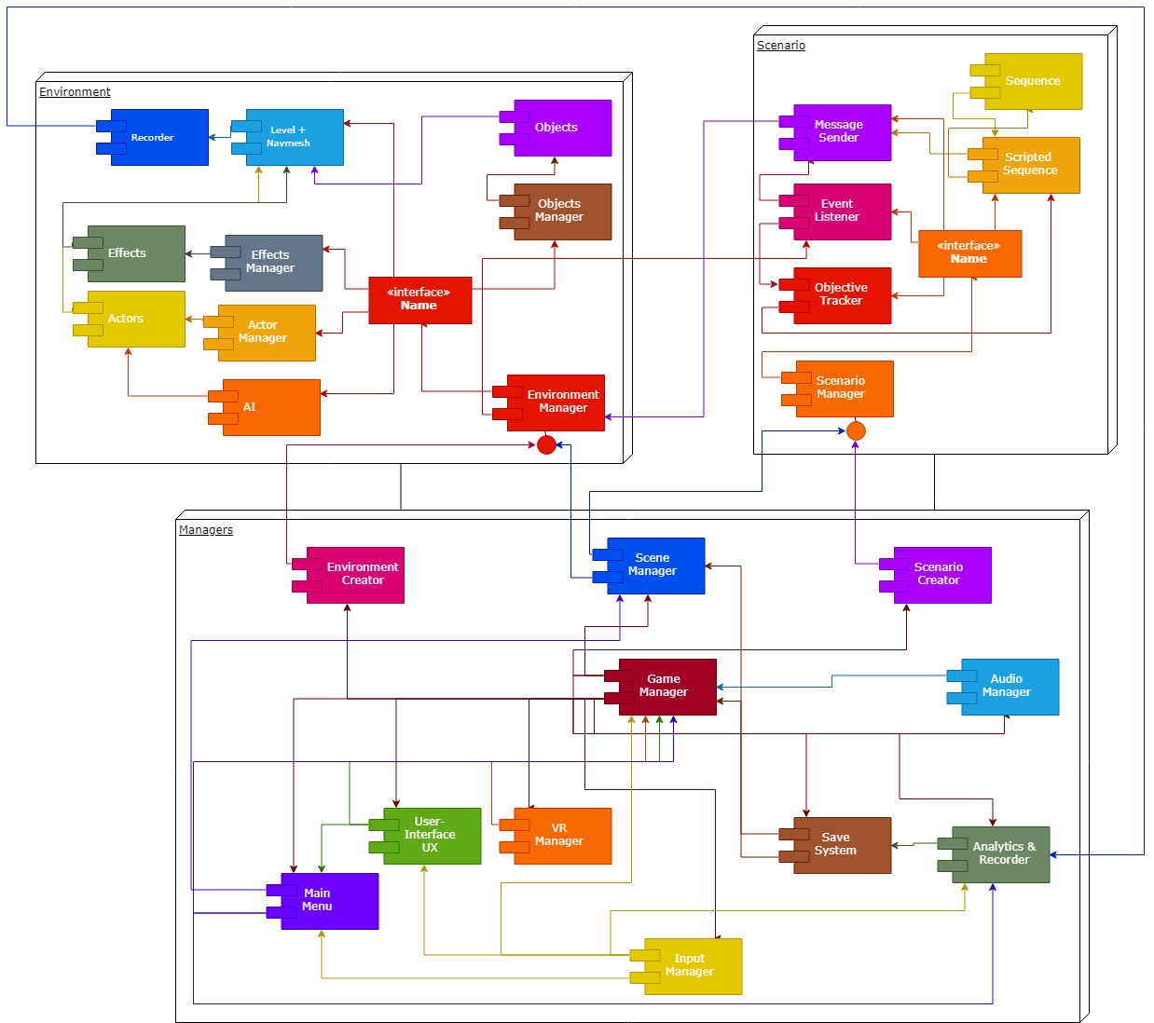

# System Design

## Design Method and Standards

MANAGERS

* Game Manager – Main manager for the game
* Scene Manager – Manager for changing scenes and holding a list of scenes
* Audio Manager – Manager for handling audio
* Input Manager – Manager for input
* VR Manager – Handles input for VR controls and other features
* Save System – Makes and stores saves files
* User-Interface UX – Making UI for VR interface and in-game objects and menus
* Analytics – For storing and organising analytic data
* Main Menu – For handling the main menu and global options
* Environment Creator – For storing and creating environments with modifiable variables
* Scenario Creator – For storing and creating scenarios with modifiable variables

ENVIRONMENT

* Environment Manager – Main manager for the environments
* Objects Manager – Manager for the objects
* Object – Holds objects data and interface
* AI – AI procedures for the Actors to play automatically
* Actors Manager – Manages all the actors
* Actors – Contains the actors and they’re variables
* Effects Manager – Manages all effects in the environment
* Effects – Contains the effect and the variables
* Level + Navmesh – Holds the level geometry and handles the navmesh data
* Recorder – Records the players actions and the other environment data

SCENARIO

* Scenario Manager – Main manager for the scenario
* Scripted Sequence – Storing and sending sequences
* Sequence – For creating sequences that play in-game
* Event Listener – Listens for events and responds
* Objective Tracker – Tracks and checks for objectives
* Message Sender – Sends message for functions

## Naming conventions

Unity advised conventions

## Software development tools

Visual Studio Enterprise 2017

## Interactive Progression

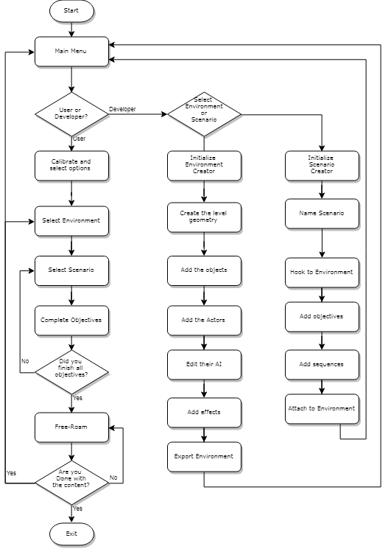

## System breakdown

##### *AI*

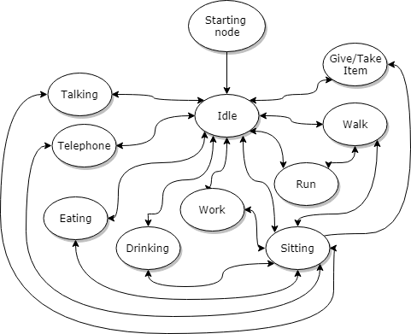

Document Control

|  |  |
| --- | --- |
| **Title:** | Research Project for the development of VR environments for people with Autism Spectrum Disorder |
| **Date:** | 10th January 2019 |
| **Author:** | Adam Michael Szlamp |

Document Change Record

|  |  |  |  |
| --- | --- | --- | --- |
| **Date** | **Version** | **Author** | **Change Details** |
| 10th January 2019 | Draft 1 | Adam Szlamp | First complete draft |